**PyCity Schools Data Analysis**

**Main Observations:**

1. **School funding does not have a positive impact on student grades, even when broken down on a funding-per-student basis. In fact, schools with greater amounts of funding per student have lower performance statistics.**
2. **While small and medium sized schools (<2000 students) have similar performance to one another in an acceptable range, larger schools (2000-5000 students) show a significant decrease in performance**
3. **There is a disparity between Charter Schools and District Schools that is similar to that between small/medium versus large schools, with Charter Schools significantly outperforming district schools**

**Recommendation: Decrease school size for better performance (likely due to smaller class sizes); try to make class environment of district schools like that of charter schools**

**District Overview:**

Two datapoints stand out based on the bird’s eye view of this district’s performance. The first is the relatively low average math score across schools, and the other is the low number of students passing both subjects **[Overall Pass Rate: 65.17%]**

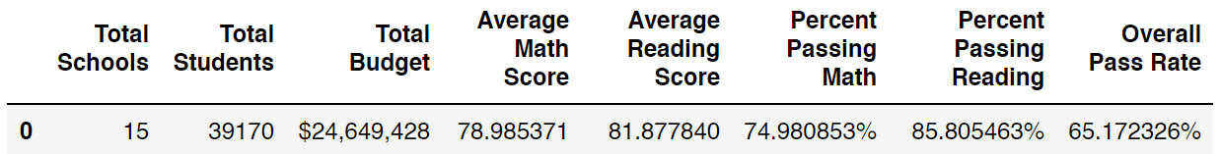

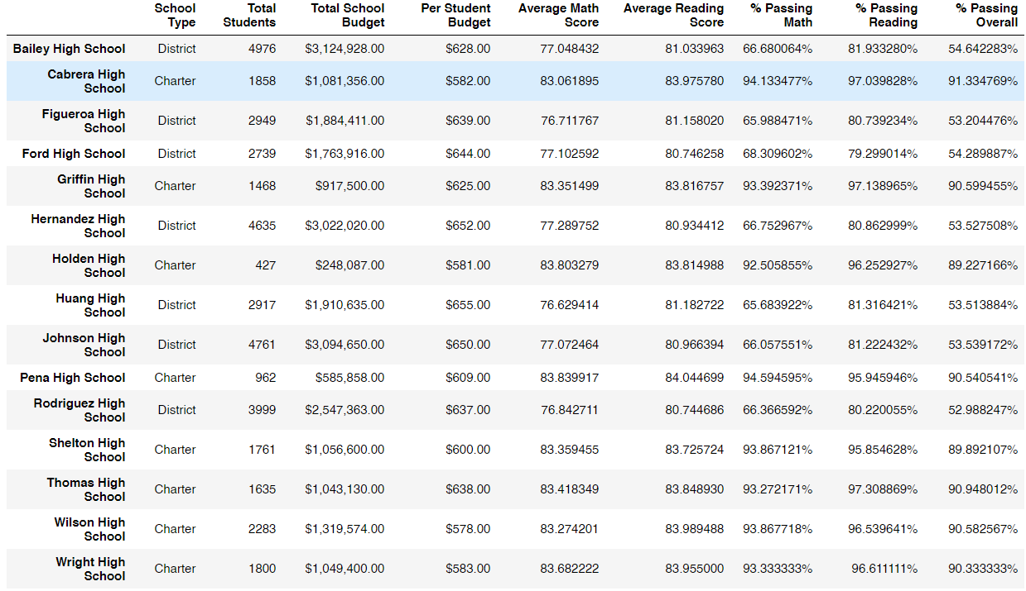**School Overview:**

A broad look at the district reveals a strong bifurcation in overall student scores, while most schools have very high overall pass rates, a few schools are barely over 50%.

**Top 5 Schools:**

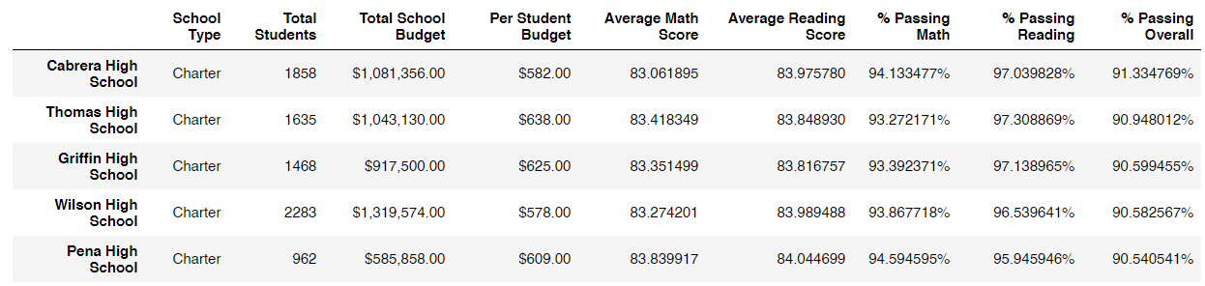

Top performing schools all have overall pass rates in the low 90%. There is a broad disparity in their funding, however most have relatively similar total student body sizes.

**Bottom 5 Schools:**

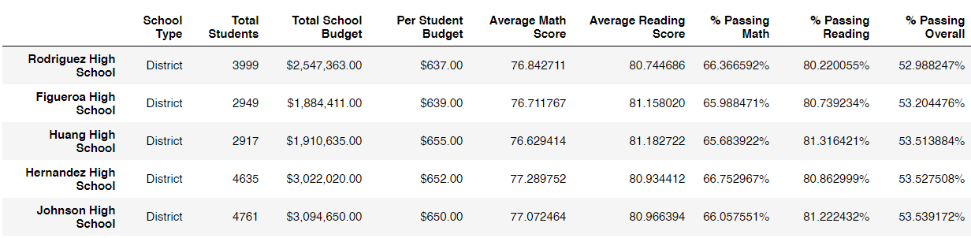

Bottom performing schools all have overall pass rates in the low 50%. There is a broad disparity in their funding, however on average they are better funded than the Top 5 schools. Furthermore, they have higher student body counts than the Top 5 schools

**Math Average By Grade and Reading Average by Grade:**

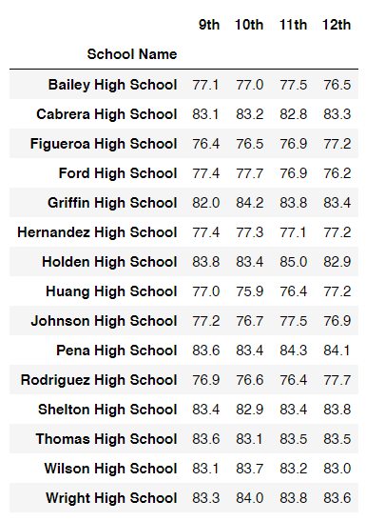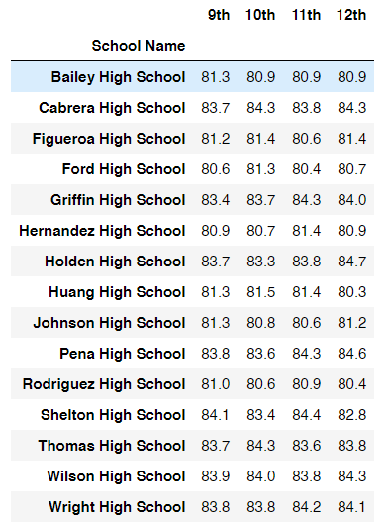

Scores by student grade reveal that grade year seems to have little impact on performance in either math or reading

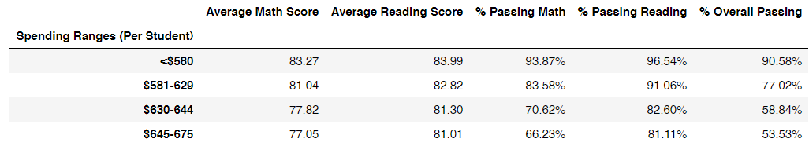**Average Scores and Pass Rates by Funding per Student:**

Confirming observations from the Top 5 and Bottom 5 schools, funding seems to have little impact on grade, even when broken down on a per-student basis. In fact, the correlation between funding and student success seems to be negative. This is a very curious trend, there must be another factor causing the disparity

**Average Scores and Pass Rates by School Size:**

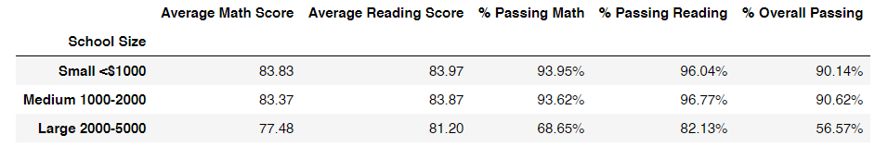

School size gives a big clue as to what might be going on, as we find the >2000 student threshold is severely impacting student performance

**Average Scores and Pass Rates by School Type:**

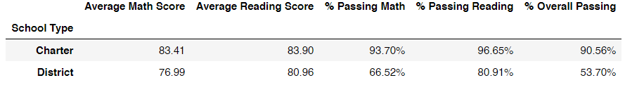

Furthermore, school type reveals a similar disparity, with Charter Schools significantly outperforming district schools